|  |  |  |  |  |
| --- | --- | --- | --- | --- |
| **Sections**  (delineated by strong arrival on C, textural changes/breaks) | **Subsection**  mm. | **Theme/Motive**  (theme, 3-6 mm.)  (motive, 1-2 mm.) | **Cadence**  (bold indicates clear textural break) | **Notes** |
| Section 1  Introduction  Canonic Imitation introduces Choir 1, then 2, then 3 | 1-10 | 1 (C, imitation at 5th) /1 | m. 6 (CM) (elided), 10 (CM) (elided) | Choir 1/Voice 3 plays only accompaniment |
| 10-15 | 1, 2 (C, imitation at 5th) /2B | 15 (CM) (elided) | Choir 2/Voices 9,10 play theme 1  Voices 6,7,8 play motive 2b |
| 14-26 | 1 (C, imitation at 5th) /2A&B | **26** (CM) | Voice 1 begins, ends section 1  Choir 3 begins with theme 1, ends with motive 2a&b  Choir 2&3 Trumpets (1,6,7) “echo” close |
| Section 2  Tripartite  First, all choirs, then choirs 2&3, then all choirs | 26-30 | 1,3 (C modulates to G, imitation at 3rd and 5th) /3 | 30 (DM) (elided) | 26-30, Choirs 1,2,3, lowest voice (5, 10, 14) plays theme 1 with voice 11  Voices 1,6,7 (the three voices that “echo” close section 1) play theme 3 |
| 31-35 | 1 (G) /3 | 35 (AM) (elided) | 31-35, lowest voices in choirs 2&3 play theme 1 |
| 35-38 | (free counterpoint) | 38 (CM) (elided) | 35-38, All Choirs |
| Section 3a | 38-41 | 1 (C) in diminution | 41 (GM) (elided) | Choir 1, Similar to mm. 1-10 |
| 41-45 | 1 (G, modulates to A) /1, 2A | **45** (AM) | Choir 3, lowest voice (14) plays Theme 1, voices 11,12,13 play motive 2A |
| Section 3b | 46-51 | 1 /1, 2A, 4 in sequence | 51 (CM) (elided) | Choir 2, lowest voice (10) plays theme 1, voices 6&7 play motive 1, 4, voice 1 plays motive 2A |
| 50-54 | 1 (in diminution) /4 | 54 (CM) (elided) | All choirs, choir 3 lowest voice (10) plays theme 1, voices 3,4,6,7,11 plays motive 4, motive 4 developed through pre-motive/motive/sequence |

|  |  |  |  |  |
| --- | --- | --- | --- | --- |
| Section 4 | 54-60 | 1 (C, in diminution) /1 and 1-inverse | 60 (CM) (elided) | Choirs 1&2, voices 2,5,6,7, theme 1 in diminution, voice 10 mm. 58-60 plays partial theme 1. |
| 59-63 | 1 (G, modulates to A) | 63 (AM) (elided) | Choir 3, all voices, lowest voice (14) initiates |
| 62-67 | 4 /2A | **67** (CM) | All choirs in canonic imitation |
| Section 5 | 67-72 | 1 (C, original and diminution, imitation at 3rd and 5th) | 72 (CM) | Choir 2, voices 6,7 diminution, voice 10, original |
| 71-76 | 1 (C modulates to D, imitation at 5th) /2A | **76** (DM) | Choirs 1&3, voices 1,5,14 play theme 1, voices 3,4,5,11,14 play motive 2A |
| 76-82 | 1 (modulates from Bb→F→C, diminution and inversion, imitation at 3rd and 5th) | 82 (GM) (elided) | Choir 2, mm. 76-78, Choir 1, mm. 78-80, Choirs 2&3 mm. 80-82. Voices 1,2,6,7, play diminution, voices 11,13 play inversion |
| 82-85 (connective?) | No theme! Motive 1(augmented), 2A, modulation from G to A | **85** (AM) | Choir 1, and voices 6,7 |
| 86-90 | 1, 2 (modulates from F→Bb→Eb→A→G) /1, 2B | 90 (CM) (elided) | Choirs 1&2, voices 1,2,6,7 play theme 2, lowest voice of choir 2 (10) plays theme 1 in diminution |
| 90-95 | 1 (does not modulate) /1, 2A&B | **95** (CM) | All choirs, lowest voice in each plays theme 1, all other voices play pervasive motivic imitation |
| Section 6  Coda (or introduction to new piece? This section makes the piece sound like a prelude) | 95-100 | 1 (in diminution) /2A&B | **100 (CM)** | All choirs |

Theme 1 (e.g. voice 2, mm. 1-6)

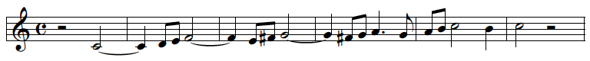

Motive 1 (e.g. voice 3, mm. 5-6)



Theme 2 (e.g. voice 6, mm. 10-15)



Motive 2 (a&b) (e.g. voice 6, mm. 24-25)

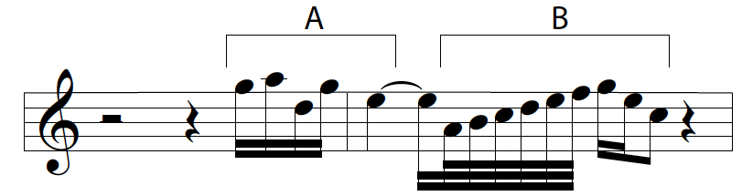

Theme 3 (e.g. voice 1, mm. 26-30



Motive 3 (e.g. voice 13, m. 30)

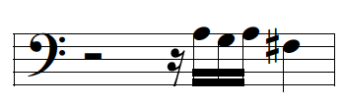

Motive 4 (e.g. voice 4, mm. 50-51)

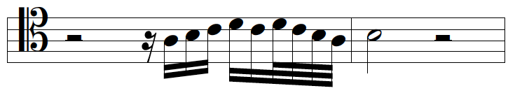

Theme 4 (e.g. voice 1, mm. 62-64)

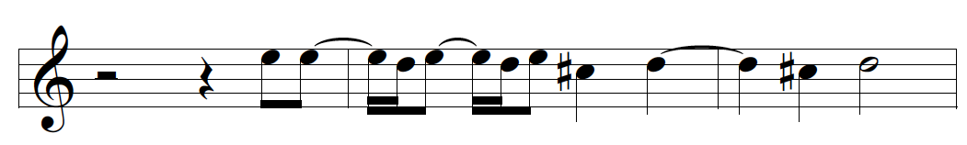

Elaborate on points of imitation, interval & delay

Reflects Italian *canzone* poetic structure, resembles Italian madrigal